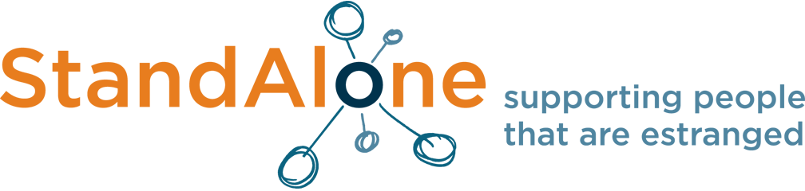

Celebrating Change: 2 years of the Stand Alone Pledge

8 November 2018, Kings College London
#SAconf1118

Programme

9.30am Registration
10.30am Welcome by Chair
Anne-Marie Canning MBE, Director of Social Mobility and Student Success, Kings College London
10.35am Review of 2 years of the Stand Alone Pledge and what next?
Becca Bland, CEO, Stand Alone
11.00am OfS: Estranged students
Chris Millward, Director for Fair Access and Participation, Office for Students
11.30am COFFEE
11.45am Launch of the research report ‘Family Matters’: an exploration of the role and importance of family relationships for students in UK higher education Prof. Jacqueline Stevenson, Head of Research, Sheffield Institute of Education at Sheffield Hallam University
12.30am The social mobility agenda and cultural change in HE
Anne-Marie Canning MBE, Director of Social Mobility and Student Success, Kings College London
1pm LUNCH with audio/visual display plinth
1.45pm Research: the experience of estranged students in higher education
Dr Rachel Spacey, University of Lincoln and Amie Key, Durham University
Student Panel
2.30pm Workshop sessions

A: A localised perspective in supporting estranged students at Higher Education
Kings College London and Kingston University

B: Active vs Reactive – creating a culture change within your university
University of the West of England

C: A collaborative approach to the Stand Alone Pledge
Go Higher West Yorkshire
3.45pm Final roundup by Chair and Stand Alone
4pm Close

Programme correct at time of publication. Sessions are subject to change.

