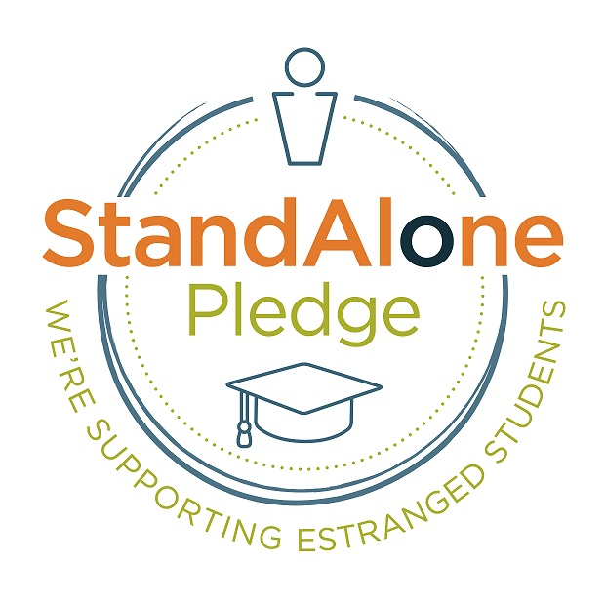
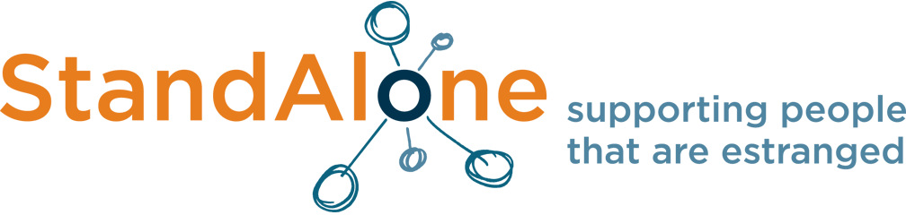

Expression of Interest: Stand Alone Pledge evaluation July 2022
- Your name

- Your current occupation

- Please outline your qualification and experience of research in a relevant field

- Please tell us why you are interested in undertaking this piece of work

- Has your research to date mainly focused on quantitative or qualitative data approaches?

- The research will need to be approved by a UK university’s ethics committee. Can you confirm your university is able and willing to do that?

- The work will need to be completed by the end of September at the latest. Please could you confirm you are able to meet this deadline.

Thank you for submitting your expression of interest to Susan Mueller, HE Director, Stand Alone: s.mueller@standalone.org.uk

