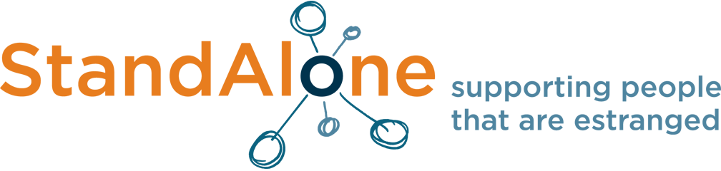

Celebrating Change: 2 years of the Stand Alone Pledge

Workshops

A: A localised perspective in supporting estranged students at Higher Education
Anne-Marie Henderson: Associate Director of Academic Support and former Specialist Student Adviser, Kings College London and Chrissie Farley: Access and Support Officer (KU Cares), Kingston University
The workshop will focus on challenges and solutions to support estranged students at an institutional (not national) level. We will compare the approaches of two very different London institutions with unique internal barriers/opportunities, but a similar demographic challenge. Participants will have the opportunity to also think about their own institutions’ ideal estranged student support provision and consider how that could be achieved.

B: Active vs Reactive – creating a culture change within your university
Steffie Denton, UWE Cares Coordinator, University of the West of England
The workshop will identify estranged students’ challenges, needs and wants and participants will work in groups to discuss and plan ways we can promote and support culture change within our institutions to reduce these barriers and improve the support that estranged students receive.
We will discuss the importance of listening to students in identifying what and how support could be changed at university.
Focusing on accommodation challenges, UWE Bristol will share how they have gone about promoting change for estranged students and the potential pitfalls and things other HE providers might want to be aware of if trying to introduce or improve new support offers.

C: A collaborative approach to the Stand Alone Pledge
Helen Sykes, Manager, Go Higher West Yorkshire
Go Higher West Yorkshire (GHWY) is a partnership covering most kinds of HE provider. Attendees are invited to join us as we outline our context and our journey working together to develop a collaborative Stand Alone pledge for our partnership’s member universities and colleges.
The workshop aims to open a dialogue with participants, to consider:
- Ways in which collaboration could be more effective in supporting estranged students
- Ways in which a collaborative approach could be effectively evaluated and developed further
- The transferability of this approach to other under-represented groups

